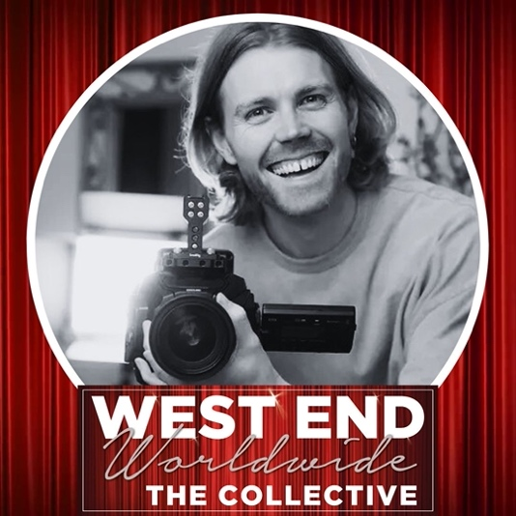
MATT PARSONS
SPECIALISING IN: ACTING FOR CAMERA | TEXT ANALYSIS | SELF TAPING | AUDITION TECHNIQUE

Matt has a unique set of crossover skills & experience, having originally trained as an actor and performing in the West End & Internationally, and now running his own film production companies MPP & Pro-Actor Showreels.

As a performer he appeared in Wicked (West End), The Sound of Music (Dubai) & Scooby Doo The Musical (London Palladium & UK Tour).

His DOP / Filmmaking work includes filming short films, brand content, app content & music videos. His personal short films have been screened at film festivals worldwide, and he regularly works with up-and-coming actors on their portfolio material. He has been teaching actors screen acting, audition technique & text analysis skills through workshops for the past 4 years.
